Study Abroad Main menu link

1 - paragraph

SpeakAbroad is a trusted education consultancy dedicated to helping students turn their dreams of international education into reality. Since 2014, we have supported aspiring learners at every stage of their journey — from selecting the right course and university to exam preparation, documentation guidance, and visa assistance.
Our goal is to help each student achieve their global academic ambitions through expert counselling, personalized support, and a seamless admission process.
At SpeakAbroad, we inspire students to pursue their aspirations with clarity, confidence, and determination. With professional expertise and genuine care at every step, we ensure you are fully prepared for a successful future abroad.
We understand that studying abroad is more than an academic decision — it is a life-changing experience. That’s why we focus on careful planning, informed choices, and honest guidance tailored to your strengths and interests.
Our experienced team stays updated with global education trends, admission requirements, and visa regulations to provide accurate and reliable advice. From your first counselling session to your departure and beyond, we remain committed to your success.
With SpeakAbroad, you don’t just apply to universities — you build a clear pathway toward a brighter, borderless future.

2 - Keep the same
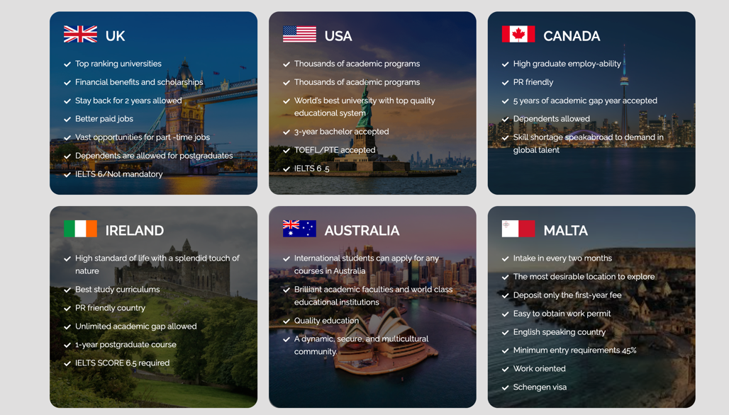

Additionally,

Austria
- Heart of Europe with high-quality education
- Public universities with low tuition fees
- Globally recognized degrees
- Spouse accepted (Masters & certain programs)
- Strong focus on research and innovation
- Safe and high standard of living
- Schengen visa benefits

Georgia
One of the fastest-growing study destinations in Europe
Affordable tuition fees and low living cost
Globally recognized universities (especially for Medicine)
Spouse accepted (Masters programs)
Simple admission process
High visa approval rate
IELTS not mandatory in many universities
Safe and student-friendly environment

Netherlands
- One of Europe’s top English-speaking countries
- World-class universities and research facilities
- Wide range of English-taught programs
- Spouse accepted (Masters programs)
- Strong job market for international students
- Post-study work opportunities available
- High visa success rate
- IELTS generally required

Denmark
- Modern and innovative education system
- Focus on practical and research-based learning
- High quality of life and safety
- Spouse accepted (Masters programs)
- Strong work-life balance culture
- Post-study work visa options available
- Scholarship opportunities for international students
- IELTS required for most programs

Italy
- Home to some of the oldest universities in the world
- Affordable tuition fees and living costs
- Wide range of English-taught programs
- Spouse accepted (Masters programs)
- Scholarships available for international students
- Rich cultural and historical experience
- Schengen visa benefits
- IELTS may be waived in some universities

3. Keep the language test accepted
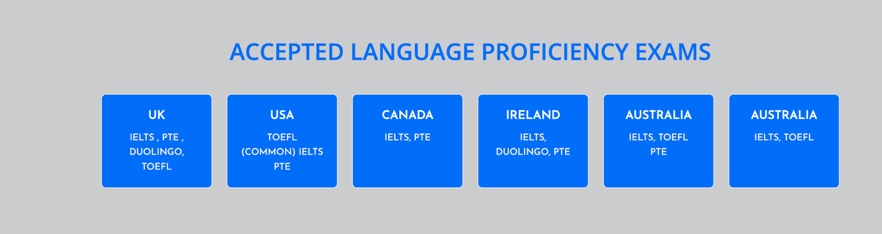

4. keep the same

